Ideation Phase
Brainstorm & Idea Prioritization Template

Date | 27 June 2025
Team ID | LTVIP2025TMID36160
Project Name | Citizen AI – Intelligent Citizen Engagement Platform
Maximum Marks | 4 Marks

Brainstorm & Idea Prioritization Template:
Brainstorming provides a free and open environment that encourages everyone within a team to participate in the creative thinking process that leads to problem-solving. Prioritizing volume over value, out-of-the-box ideas are welcome and built upon, and all participants are encouraged to collaborate, helping each other develop a rich amount of creative solutions..
This inclusive approach fosters innovation by allowing diverse perspectives to surface and evolve. It breaks down communication barriers and promotes equal contribution from all team members. By focusing on creativity before filtering ideas, teams can uncover unique solutions that might otherwise be overlooked. Whether remote or in-person, this method builds momentum and lays a strong foundation for meaningful, high-impact decision-making.
In the context of the Citizen AI Intelligent Engagement Platform, brainstorming empowers the team to reimagine how citizens interact with government services. Ideas can range from AI-powered chatbots to multilingual support systems, ensuring inclusivity and accessibility. By encouraging contributions from developers, analysts, and civic planners, the team uncovers diverse solutions rooted in real-world needs. Grouping ideas into themes like feedback analysis, real-time dashboards, and service automation helps streamline development. Prioritizing these based on impact ensures the most valuable features are delivered first. Remote collaboration tools like Mural enhance the experience, enabling seamless input from all stakeholders. This approach not only improves citizen satisfaction but also enhances transparency and government responsiveness. Through structured creativity, the team can transform complex civic challenges into smart, scalable solutions.

Step-1: Team Gathering, Collaboration, and Select the Problem Statement

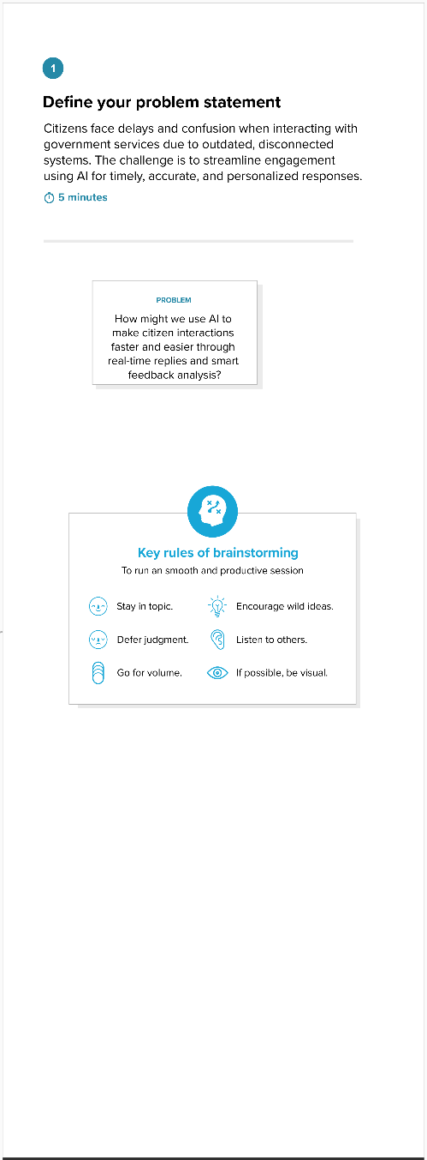

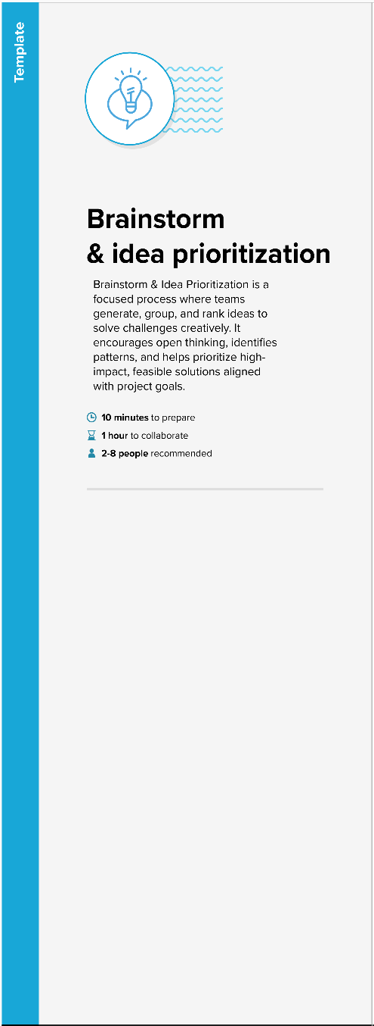

Step 2: Brainstorm, Idea Listing, and Grouping

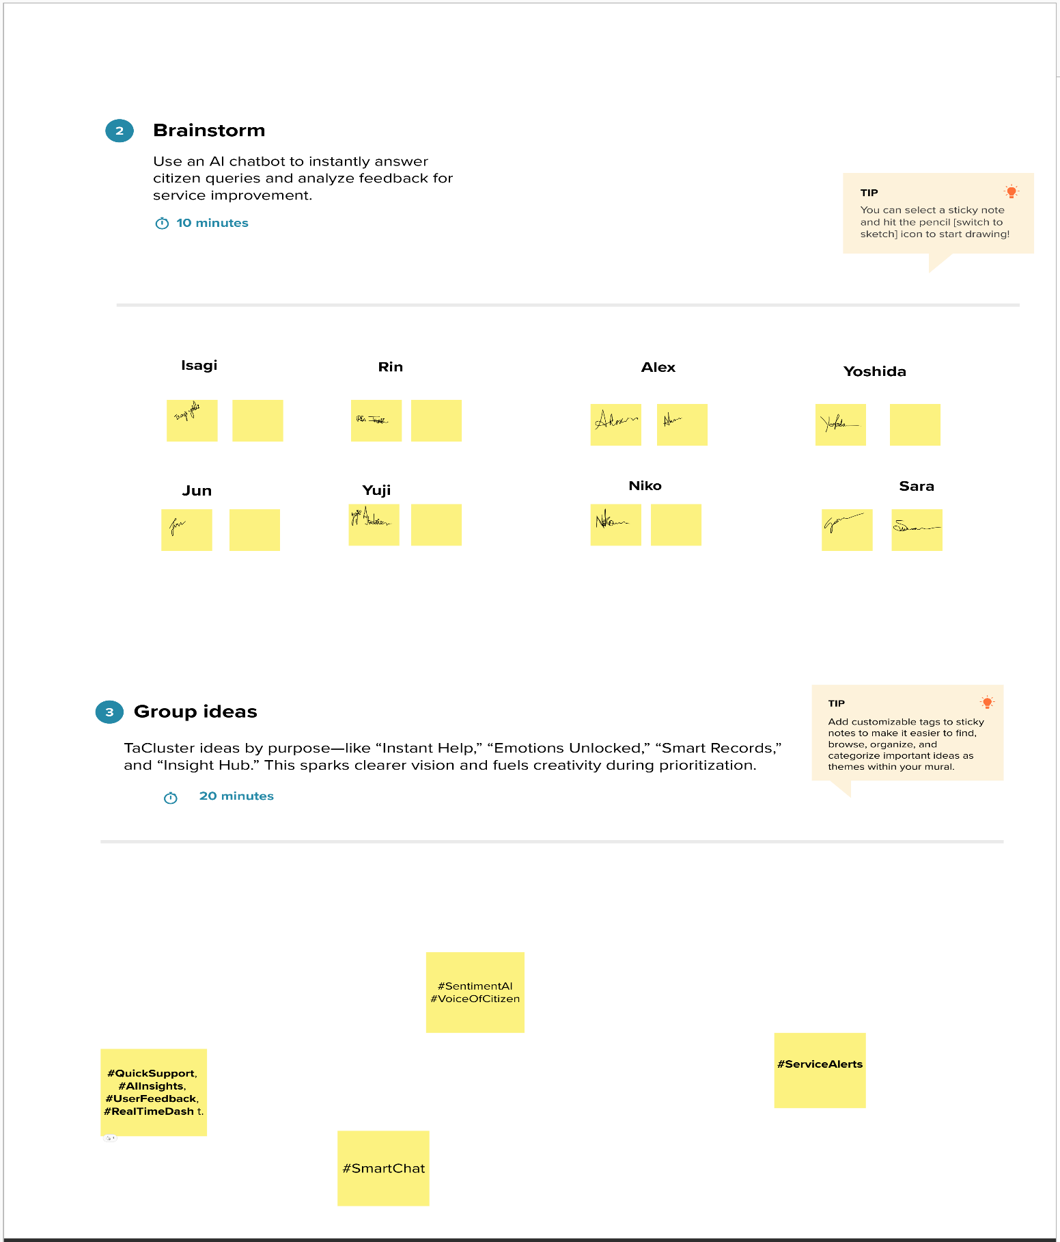

Step 3: Idea Prioritization
